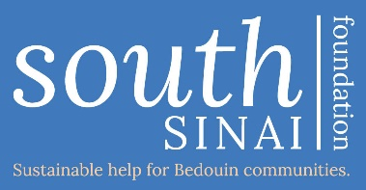

South Sinai Foundation
Privacy Policy

- South Sinai Foundation (SSF) is a small UK charity that works in collaboration with Bedouin communities in South Sinai, Egypt for the improvement of those communities.

- We only collect or process personal data where necessary to:

- communicate with trustees or staff
- fulfil a request from a supporter or interested party ie joining our mailing list or keeping up-to-date with our work
- process donations and Gift Aid claims
- comply with the law ie keeping records of donations and Gift Aid claims.

We never use data other than for the specific purpose it was collected. We only hold personal data for as long as is necessary to fulfil our obligations listed above.

- We hold data securely within our team of UK trustees and we never share personal data with third parties. If we are required to share personal details with our partners in Egypt, we always seek explicit, additional consent to do so.

- Where there are any planned changes to how we collect, use or manage personal data, we will inform all affected parties in advance as soon as possible.

- Unsubscribing and withdrawing consent

You can withdraw consent for us to hold your personal information or unsubscribe from our mailing list at any time by emailing info@southsinaifoundation.org or by writing to us at South Sinai Foundation, St Katharine’s Cottage, Ingoldsby, Grantham, Lincolnshire, NG33 4EW. Where there is no legal obligation for us to keep your data, we will act on your request as soon as your communication is received. Where there is a legal obligation for us to keep your data, we will inform you of the length of time remaining before we are able to permanently remove your details.

- Cookies

Our website is hosted by Wix, an organisation which uses cookies. SSF does not monitor or collect data on visitors to our website but as an independent organisation Wix does collect some data via cookies. The cookies Wix uses are:

Cookie name | Life span | Purpose
svSession | Permanent | Creates activities and BI
hs | Session | Security
incap_ses_${Proxy-ID}_${Site-ID} | Session | Security
incap_visid_${Proxy-ID}_${Site-ID} | Session | Security
nlbi_{ID} | Persistent cookie | Security
XSRF-TOKEN | Persistent cookie | Security
smSession | Two weeks | Identify logged in site members

You can learn more about managing and controlling cookies by clicking the ‘Use of Cookies’ link at the bottom of each page of our website.

- Data Officer
If you have any questions or issues around our use of personal data, please contact our designated data officer, Lucy Gilbert (SSF trustee) at info@southsinaifoundation.org or contact our chair, Hilary Gilbert, directly at St Katharine’s Cottage, Ingoldsby, Grantham, Lincolnshire, NG33 4EW. We will respond to you within 21 working days of receiving your communication.

